|  |  |
| --- | --- |
| **SURNAME:** | Ramjee |
| **NAME:** | Bhavir |
| **STUDENT NUMBER:** | 21443026 |
| **GROUP:** | Group 2 |

**Instructions:**

* **Please answer the following questions by means of any of the following methods:**
  + **Fill in your answers on this document (electronically) and save in Word/PDF;**
  + **Fill in your answers on a separate piece of paper (by hand) and scan it in/take a photo.**
* **Please submit it through attaching your attempt to the link on the BER 210 ClickUp page, under the content area “Tutorial Submission Links”, through clicking/tapping on the link “TUTORIAL 1: SUBMISSION LINK”.**
* **Then attach your attempt by clicking/tapping on “Browse Local Files”:**

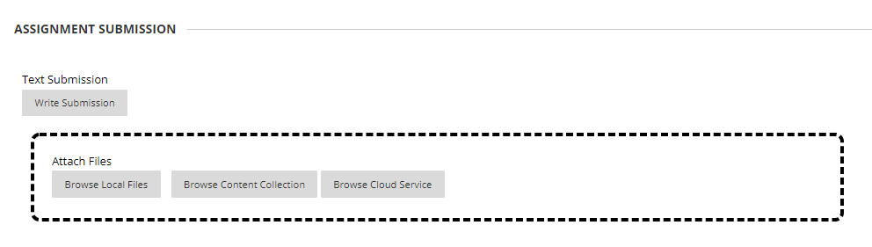

* **When finished click on “Submit”:**



**___________________________________________________________________**

**Questions:**

**Question 1**

Joey and Dianne were married out of community of property with the accrual system. At the time of concluding the marriage, Dianne’s estate was worth R2mil and Joe’s estate was valued at R0. During the next 10 years Dianne attended to the children born out of the marriage and assisted Joey with the administration of his cell phone business. At the date of divorce, Joey’s estate was valued at R5mil, but Dianne’s estate was still R2mil. Calculate the accrual. **(4 marks)**

1. Thabo:
2. Sipho:
3. Portia:

**Answer:**

Dianne accrual: R0 and Joey accrual R5mil

**Question 2:**

Catherine and Dianne agree that Dianne will sell certain unpolished diamonds for R4mil to Catherine.

2.1 Is the contract valid? Motivate your answer. **(4 marks)**

**Answer:**

Yes it is because they both agreed that the sale of unpolished diamonds will occur.

2.2 If Dianne had already delivered the diamonds to Catherine and Catherine cannot pay, what remedies would Dianne have? **(4 marks)**

**Answer:**

She would be able to state in the contract that

**Question 3:**

Beatrice (B) works at a company Top Secret (TS), where various important vaccines are formulated. These vaccines include the new malaria vaccine, Covid vaccines and she is also busy with designing a vaccine that will be effective against certain cancers. Only Betty has the brains to formulate this vaccine. B’s contract includes a restraint of trade clause, whereas she is not allowed to compete with TS by working in a similar capacity (that of vaccine formulation) within the borders of South Africa for a period of 5 years.

Discuss whether this restraint of trade is valid and enforceable by considering all the factors a court will take into consideration. **(10 marks)**

**Answer:**

Click or tap here to enter text.

**Question 4:**

Steve, who is 17 years of age and his friend Lily, who is 21 years of age bought a dining room set for R12 000 from Betty who is a supplier of household furniture. Steve told Betty that he is 19 but Betty never asked for his Identity Document. Explain the legal status of the agreement. **(6 marks)**

**Answer:**

It is not legal because Steve lied about his age therefore it makes the legal agreement invalid and also because Steve is not 18 he cannot legally enter into contracts

**Question 5:**

Identify whether the following contracts are valid. Motivate your answer.

5.1 Rodger and Sophia agreed that Sophia will engage in an adulterous relationship with Rodger so that Sophia could get the promotion she applied for. **(4 marks)**

**Answer:**

It is invalid because it is not legal to commit such acts to to receive a benefit at work and adultery acts are illegal.

5.2 Andrew and Benny agreed that Andrew would hijack a cash-in-transit vehicle and steal the money. **(4 marks)**

**Answer:**

Invalid because they are committing a crime no contract would be legal to motivate an act of crime.

**Question 6:**

Abel is a very expensive second-hand car supplier. Bean is desperately in need of a car since his current car has reached its lifespan, however he cannot afford to purchase a new car and is therefore in need of a second-hand car. He is referred to Abel and accordingly contacts Abel for a quote. Unfortunately, the quote from Abel is significantly higher than other suppliers (it is the equivalent of a new car). Bean ultimately decides to go with another supplier who is cheaper than Abel and offers some good benefits. Abel was anticipating Bean to purchase the car since he has not made enough sales in the month of March. Unhappy to hear about Bean’s decision, Abel confronts Bean and threatens him with a gun that if he does not purchase the car from him, he will harm both Bean and the other supplier. Scared to be harmed and in protecting the other dealer, Bean enters into a purchase and sale agreement with Abel.

Explain whether the above contract is valid based on the facts. **(8 marks)**

**Answer:**

It is invalid because Bean did not formally agree to enter into the contract therefore the above is invalid. Also because Abel threatened Bean with a gun saying that he will harm him if he does not buy the car from him. Therefore it is invalid because threatening someone with force is illegal.

**Question 7:**

Explain the three situations where a minor will not be bound to a contract. **(6 marks)**

**Answer:**

First is when a parent/guardian acts of their behalf and not on behalf of the minor. A second is where the minor acts as the guardians agent and the guardian acquires the rights flowing from the representative act.

**Question 8:**

Distinguish between the *par delictum* rule, the *ex turpi causa* rule and the parole evidence rule. **(6 marks)**

**Answer:**

Par delictum rule holds that where both parties are to blame for the unlawful contract the right of the possessor of the performance is stronger. Ex turpi causa rule says that no legal action may be instituted on the alleged contract by any party. Because no valid contract came into being, the normal contractual remedies such as specific performance.

**END**